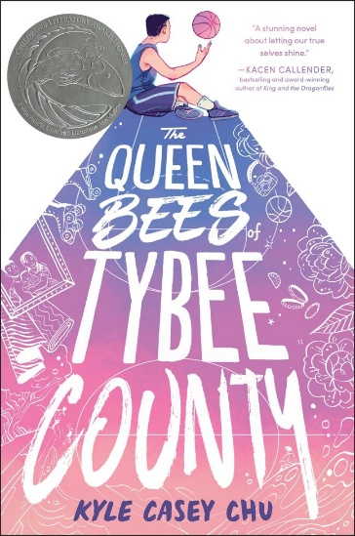

The Queen Bees of Tybee County by Kyle Casey Chu
Publisher: Quill Tree Books, an imprint of HarperCollins Children’s Books
Year First Published: 2025
ISBN: 9780063326958 (hardcover)
*Age Range: 8-12 (Suggested by Publisher)
Grade Range: Gr 6 Up (Recommended by School Library Journal)

BOOK SYNOPSIS
After making the buzzer-beating shot at the Georgia basketball state championships, Derrick Chan becomes the star of Bayard Middle School, and Derrick’s single dad could not be prouder. But there are parts of Derrick that no one knows about, like the toenail polish he wears under his basketball sneakers, his secret lip-sync performances in the bathroom mirror, and the feelings he’s developing for his best friend and teammate, JJ.
As the school year comes to a close, Derrick’s dad takes an out-of-town job and ships Derrick off to spend the summer with his estranged, eccentric grandmother, Claudia. Soon, Claudia introduces Derrick to the world of small-town southern beauty pageants, and Derrick suddenly feels he’s found where he belongs. But when the opportunity arises to compete in the town pageant, Derrick is forced to decide just how much of himself he’s ready to show the world.
Can he learn to love and accept the most unique parts of himself? And what will happen if others—like his father and JJ—can’t do the same?

- A Star on Two Courts: Derrick is a basketball champion, but he finds his true calling on a different kind of stage, discovering the glamour and courage of drag performance.
- Found Family: Sent to his eccentric grandmother Claudia’s house, Derrick finds unexpected friendship with fellow misfits Ro and Giles, who help him find the confidence to be himself.
- Best Friend First Crush: Navigating secret feelings for his best friend and teammate JJ adds a whole new layer of complication to Derrick’s transformative summer.
- Heartfelt and Humorous: Perfect for fans of Better Nate Than Ever and Dumplin’, this story is packed with laugh-out-loud moments and poignant lessons about self-acceptance and family.

REVIEWS AND PRAISE
★ "A kind contemplation on generational trauma, race, and queer identity in the South, this book sparkles with queer joy." —Booklist (starred review)

"In this emotionally grounded tale about becoming one’s true self, Chu carefully balances an affirming coming-out narrative with honest, approachable accounts of familial secrets, intergenerational trauma, and systemic racism and homophobia." —Publishers Weekly

"This book tenderly follows the classic coming-of-age formula. Chu’s personal connection to the narrative, as a drag performer and founder of the Drag Story Hour organization, comes through passionately." —Bulletin of the Center for Children’s Books

"An important book for middle school shelves, and for any reader seeking a positive role model demonstrating courage and strength in the face of challenging situations—even when it’s family who might pose the biggest obstacle." —School Library Journal

“The Queen Bees of Tybee County is a heartfelt celebration of authenticity that asks us all to follow our joy. Laugh out loud funny and tear-jerkingly emotional, Kyle Casey Chu has gifted younger and older readers alike with a stunning novel about letting our true selves shine. These characters and their triumphs will stay with me for a long time.” —Kacen Callender, award-winning author of King and the Dragonflies and Hurricane Child

“Kyle Casey Chu has given us a novel about the daring it requires to see our full selves, and the exhilaration and rightness of embracing who we are. A joyful, glittering, loving debut by an author to watch.” —Nina LaCour, Michael L. Printz-winning author of We Are Okay and Watch Over Me

“This sweet and surprising book just ramps up the excitement the deeper it gets. Marked by unforgettable characters, and teenaged joy and angst that feels so real, this is a spectacular debut!” —Michelle Tea, award-winning author of Modern Magic

“Kyle’s debut dazzles with heart in this bold, beautiful story about embracing your true self and the value of having an affirming community behind you every step of the way. Derrick Chan has my vote for queen bee of queer middle grade this year.” —Taylor Tracy, author of Stonewall Honoree Murray Out of Water

AWARDS AND ACCOLADES
- 2025 CALIBA Golden Poppy Award, Middle Grade Winner
- 2026 Asian/Pacific American Award for Literature, Children’s Honor
- 2026 Lambda Literary Award, LGBTQ+ Middle Grade Finalist
- 2026 Pedro and Daniel Intersectionality Book Award, Middle Grade / Young Adult Finalist
- 2026 CALA Best Book Award, Juvenile Literature Winner
- 2026 Indie Choice Awards, Debut Children’s Finalist
- 2026-2027 Vermont Golden Dome Book Award, nominee
- 2026-2027 Maine Student Book Award, nominee
- NYPL’s Best Books of 2025
- Booklist’s 2025 Editors' Choice List
- School Library Journal’s 2025 Best Books List
- Center for the Study of Multicultural Children’s Literature’s Best Multicultural Children’s Books of 2025
- CBC’s 2026 Best Children's Books of the Year, Twelve to Fourteen - Social-Emotional Learning

MEDIA AND RESOURCES
- Meet Kyle Casey Chu AKA Panda Dulce: 2025 Rainin Arts Fellow In Film | YouTube
- (Official Trailer) After What Happened at the Library | YouTube
- After What Happened at the Library (Film Website)
- Her Drag Story Hour Was Interrupted by the Proud Boys. No One Was Held Accountable. | KQED
- Pride Month 2025: Q & As with Children’s and YA Authors Celebrating Queer Culture and History | Publishers Weekly

*A NOTE ON AGE RANGES
A publisher-suggested age range covers the gamut of readers that publishers envision using the book, whether for independent reading, family sharing, group study, or in other ways. Educators have the best sense of the appropriate age range for the diverse learners they work with and understand these ranges vary depending on a book’s intended use.

