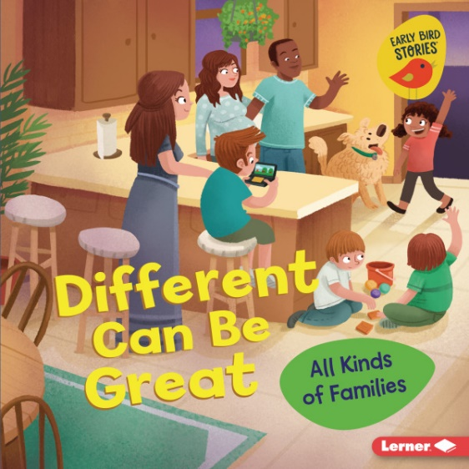
BOOK RESUME: DIFFERENT CAN BE GREAT

Different Can Be Great: All Kinds of Families by Lisa Bullard and illustrated by Renée Kurilla
Lerner Publications, Lerner Publishing Group, 2022
ISBN: 9781728436890 (Hardcover)
*Age Range: 5 – 8 (Suggested by Publisher)
Grade Range: Gr K – 2 (Suggested by Publisher)

BOOK SYNOPSIS

Makayla's family is about to change with her baby brother's arrival. She goes on a mission to see how families are each unique. Readers discover how families are different and that different is great!

MEDIA AND RESOURCES

Lerner eSource™ - Classroom Activity
Lerner Blog – Book Lists for Your Program

